Invitational Report: Gerardo Godinez
Gerardo Godinez
Special thanks to Reid Schmadeka for translation. - ed.
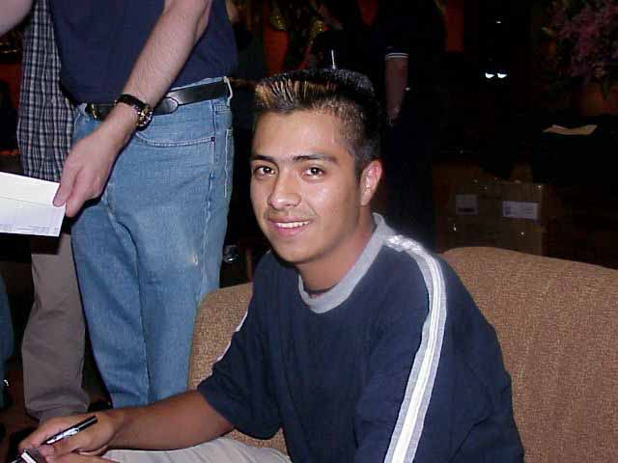
"The player with the best ranking in Latin America had a space reserved at the Duelist Invitational 2000 in Sydney, Australia." With these words, Jeff Donais gave the official announcement, confirming a rumor that had been talked about before the Latin America Championship.
After two years in first place in Latin America, after eleven Pro Tours and two World Championships, I had in my hands the great opportunity to demonstrate my achievements as a player against fifteen of the best players in the world. It was only a question of maintaining my ranking to get there. Two PTQs and one Worlds later, with favorable results, I received the official invitation from Mark Roswater. Here started my preparation for this great event.
When I had the Invitational information in my hands it was a big surprise, because I had never played a single game from any of the five formats that we were going to play. Formats like B.Y.O.B. and Auction of Champions immediately called my attention. I didn't know where to start, since at the same time there were two other events coming up: Grand Prix - Buenos Aires and Pro Tour - Chicago. At the beginning it was difficult but thanks to my team, Necrotower (Julio Cesar Ayala, Hugo "Ocho" Araiza and Alex Sacal) things started to get easier. We could divide the testing for the three tournaments. With respect to the tournament in Sydney they always let me know their opinions about the Invitational formats, so I began forming clearer ideas on how I could play there. But the most important thing were the words that one of them said to me: "Take it easy, go to play Magic and HAVE FUN!"
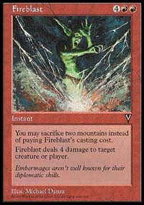
I didn't have much time but whenever we discussed the Invitational I tried to get the most benefit out of it. The only thing we could do for the Limited events was imagine the best way to play since, just like me, none of my teammates had any idea how to play them. Because of this, I focused more on the Constructed formats. For B.Y.O.B., which received most of my attention, I started to make decks. I loved that there were so many options. From the start, I thought that the best deck that anyone could make was a Mono Red from Tempest, Visions and Urza's Destiny since it had quick creatures like Jackal Pup and Mogg Fanatic, and had the power of Fireblast in Visions, and the best thing to complement it seemed like Destiny with Powder Keg and Kjeldon Champion. I built this deck and liked it, then started to think about how to play it, but also I tried other options like Trinity Green with Ice Age, Nemesis, and Destiny. Ice Age had cards like Fyndhorn Elves and painlands, Nemesis brought Blastoderm and Tangle Wires, and Destiny had Rofellos and Plow Under. Also, I tried to build a Replenish and the classic Living Death, and with these decks I prepared for the B.Y.O.B. The first thing I thought about the Auction of Champions was to bet everything on Zak Dolan's deck since I loved the idea of playing with Moxes and Black Lotus. I thought that everyone else would bid for the Academy deck that appeared better. We started to see which would be the better strategy but in truth it was very complicated. I came to think that the best was not to pay anything until only I remained to pick the last deck, having 7 valuable cards and my 20 points of life. 5 minutes was enough to get that idea out of my head, and I started thinking about what really would be the best way to do the auction. There were days that I couldn't sleep because I didn't know how I would do it, seriously! So I opted for waiting until I was there and not keep worrying about it. I decided that I would try to follow the draft tactics of someone else.
Type 1: I knew that this was the most difficult format, since to start with my best cards were Lightning Bolts and in all of Mexico there was nobody that had the top Type 1 cards. I knew that my first and best option would be a Mono Red deck transformed by some 7 or 8 cards, but I didn't worry since I knew that this type of deck could become so aggressive that it didn't matter what was in front of it. I knew that though I could go 0-3 I could also get a decent result. I had only one thing that bothered me about my Type 1 deck, just like the B.Y.O.B., which was the bad experience that I had at Worlds in Tokyo with a Sligh deck. I needed a 3-3 record on Day 3 to be in the Top 8 and disgracefully I went 0-6. But also that made me want to play it more to get that thorn that out. This is how I finished my preparation (which wasn't much) for the Invitational.
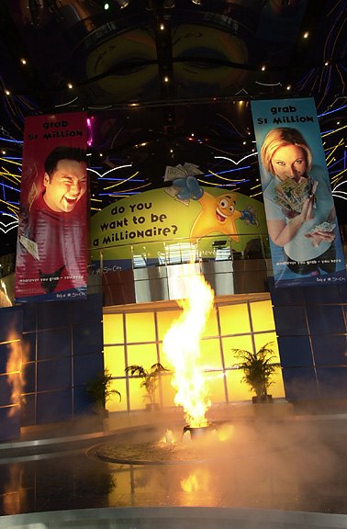
Everything was ready with my plane ticket and visa in hand. I only had to wait for the day. Since before arriving in Australia I had a layover in L.A., the flight was almost a day long and I was very tired. But in the Sydney airport I started to see what was for me a dream come true: I was at the site of the Magic Invitational and, even better, I was one of the participants! Immediately I headed to the hotel where the tournament would take place, which was certainly stupendous (good for Wizards). I checked in to my room and immediately left to see the place where I would be for almost a week. I was impressed with a better Sydney than I had imagined would be left after the Olympic Games that had finished a few days before. Finally, after a trip around this very cool city I returned to the hotel casino only to be swindled by the large number of 21s that the dealers drew. That night everything was even better. How? I started to see each time more the Magic ambience. I started to see people I knew and I felt still better. To see players like Jon Finkel and staff people made me feel like I was home.
Now the best part: the days of the Invitational.
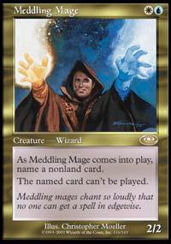
1st Day. The players meeting and other things were scheduled for the afternoon, and with all the players together Mark started. I felt like one of the best by being with the best. All of them appeared happy, all of them talking and me because of my less-than-perfect English (which I promise I will learn) I only observed. The best part of this day was when everyone received a copy of Pikula's card from the previous Invitational, which certainly will be a great card. Now that we had all the tournament information, I thought I knew what to expect.
2nd Day. The city tour and the photo session looked like they would be interrupted by the rain. Finally it started. Everyone in the bus was happy; I didn't see anyone that wasn't enjoying the trip, joking and singing. When we were beside the majestic Opera House the rain stopped, and we all took the required photos. I like the photo I took the most.
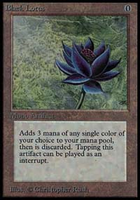
Worth three mana?
3rd Day. The tournament started with 3 rounds of Duplicate Limited. In this everyone was given identical cards and with those we made our decks. The cards were already known and there weren't any we didn't understand, but the differences were the costs of playing cards, for example Black Lotus cost 3 colorless and the rest more. When I saw the cards, I knew that the games would be long since the best cards were above 5 mana. I opted to make the fastest deck possible with what few creatures and cheap spells I could. My deck ended up being 3 colors: green, red, and black.
Given that I don't remember exactly all the details of the games, I'll give you what I can remember. I hope you understand, there were so many games it's hard to remember it all.
1st Round versus the former World Champion, Kai Budde.
During the first game he had to mulligan and had to play first. He had mana problems while I on the third, fourth, and fifth turn played creatures including Maro who finished him. The next game I started. The game ended when I played Maro again supported by a Nekrataal the following turn. His bad luck continued, this time because of too much land. Result: Victory 2-1.
2nd Round vs. the former Champion of the Invitational Pikula.
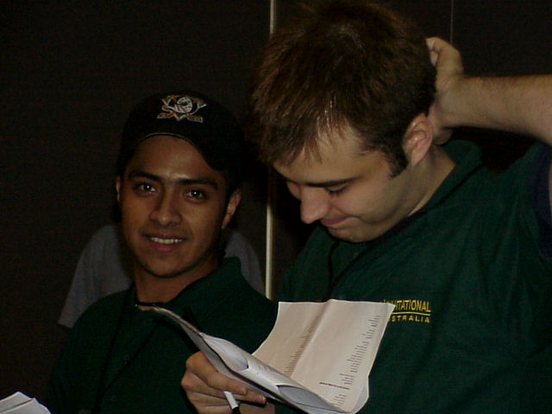
Definitely a surprise was the Winter Orb, which he didn't want and even less the moment when I cast it, since he had just tapped 6 mana and it was difficult for him to protect his Maro, untapping only one land per turn. Second Game: With a combo that I think all the decks had (5th turn Maro, 6th turn Bone Shredder), it wasn't difficult for him to beat me. The third started very slow thanks to a fast Winter Orb. It was difficult because playing a creature was risky for both of us. After Goblin Bombardment and 2 Rukh Eggs (counting the one he stole from me), it looked like everything was in his favor. Immediately I started looking for an advantage, since I thought I could end with the Giant Growth and Berserk I had in my hand. He attacked with the 2 Rukh Egg without knowing my possible win. He had tapped out and during my turn I played an Avalanche Rider and 2 other creatures so I'd have a better chance of getting off my combo (the Growth and the Berserk), but I still needed one more land and I had to wait until he attacked with his 2 creatures. During his turn he did what I thought he would and attacked me to drop me to 4 life. My turn came with the moment where I needed to topdeck a land. I drew, and sadly it wasn't a land. That moment ended the game and the match. Result: Defeat 1-2
3rd Round vs. Bob Maher Jr.
Another player who dreaded the Winter Orb (it appeared I was the only one playing it). The first game, the moment he tapped everything I cast the Orb and I had the creature advantage. This ended the first game. The second game the same thing happened and he didn't draw any land. He kept casting creatures, but in the end it wasn't enough. Result: Victory 2-1, and 2-1 in the format.
The day continued with 2 rounds of B.Y.O.B., and after some short testing with Gary Wise I decided to play my mono red, which I mentioned before with a change at the last minute. I played Alliances to get Pillages and Pyrokinesis.
4th Round versus Darwin Kastle (Survival with Ice Age, Legacy, Exodus)
With Survival on the table and Ashen Ghouls in the graveyard, the game ended, I couldn't do anything against that. In the second game, he dropped Survival but this time I attacked his land with Stone Rains and Pillages, supported by Pups and Fanatics. In the third game I had to mulligan to 5 cards. From that moment, the game wasn't in my favor and less when he played Survival on the second turn. I still managed to put up a little bit of a fight since he only drew land, but when he was one turn away from death he played a Hermit that killed me. If I'd had an extra Mountain I could have reset the game with my Apocalypse, but I couldn't. Result: 1-2 defeat.
5th Round vs. Ben Rubin, Mr. Second Place (Counter Phoenix with Tempest, Legacy, and Alliances I think)
Of this game I only want to give the result since I was totally humiliated. Result: 0-2 defeat.
6th Round versus Mike Long (Control Red with Tempest, Legacy, Alliances)
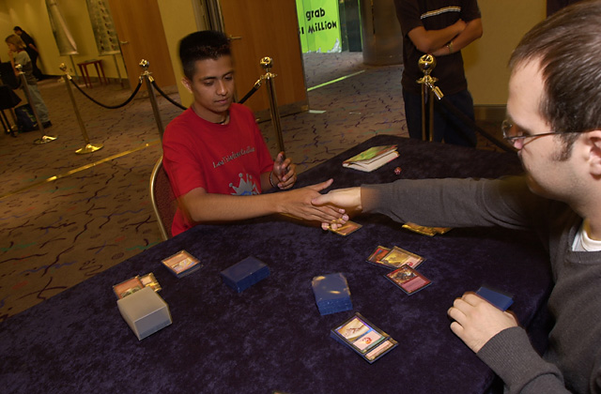
From the start I thought this match was not in my favor, since his advantage in land destruction was difficult for me to deal with. That's what happened the first game, with a Ancient Tomb and Stone Rain the 2nd turn. He started to take the advantage, finally killing me with Avalanche Riders. But the story changed in Game 2 when I was the one that started destroying lands. I killed him with my Pups. For the third game, he started and repeated the first game, but this time I want to mention the 4 Avalanche Riders he played against me. In this match it depended on who went first, and that bore out since he started two times. Result: 1-2 defeat, 0-3 in the format, 2-4 in the tournament.
For the next 3 rounds we had the difficult Solomon Draft. In truth, I can't detail how this format is since for me it was difficult to understand the strategy to follow.
7th Round vs. Trevor Blackwell, one of the best Limited players
With both our 5-color decks, we started. In the first game my multicolor scrub tendency was sufficient to make me lose. For the second game the same thing stopped me at the moment I was getting back into the game. We were the first to end our match. Result: 0-2 defeat
8th Round vs. Zvi
At this point, I looked back at the Worlds which I lost a game I thought it impossible for me to lose and began my fall to the depressing 65th place at the end of Worlds.
From the start of the draft, I noticed an advantage his deck had over mine, and I started losing from the first with the top deck of a Harrow so he could cast a Breath of Darigaaz. For the second game, a 13/13 Multani Maro Sorcerer gave him no options but to think about the third game. Of the third all I remember was that there was a moment where I had a Verdeloth that had some tokens and he had a Sliver Queen that was what gave him the game. I want to mention that I never drew a Plains so I could play the Mageta I had in my hand since my first draw. Result: 1-2 defeat.
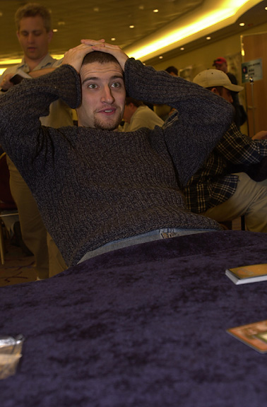
Finkel gets taken down
9th Round vs. The Jon Finkel (with whom I wanted to play since the beginning)
After a draft during which I committed various errors, I somehow ended with my deck having a distinct advantage over his. I was anxious to start. I had my maximum concentration, I started putting pressure on him and when he started one of his dangerous reactions I played a Dark Hatchling that gave him no way to come back. In the second game, he played Blind Seer very early, nullifying the majority of my creature destruction and he won. Of the third game I only want to tell about the final part which was the best. He had a Blind Seer with a white Djinn from Invasion and a 2/2 pro-green flyer. I had 3 creatures that for this situation were worthless, but in my hand I had the Dark Hatchling. I didn't have a second Swamp, but this time I was able to topdeck one and my only opportunity was to make him commit an error (which he did, and I'll tell you why). He had the Seer on the table and didn't need to do anything but control me, but when I attacked with my creatures he blocked in such a way as to save his angel. He made it pro-black and remained tapped out. It was then I played the second Swamp and cast the Hatchling and killed the Blind Seer. The game turned around 360 degrees since he had 2 creatures now and I had 4. His angel that was going to kill me died 2 turns later, and I returned to win. Result: 2-1 victory. In the format I ended 1-2 and in general 3-6.
Auction of Champions was the next in the site of Grand Prix Sydney. Everything started with Finkel's offer. It continued until I got Tom Champeng's deck, a white one that managed to defeat all the Necro decks 3 years ago to win Worlds. I liked the deck since in the environment there were many Necro and Artifact decks. My deck was good since I had 12 pro-black knights and against artifacts I had 4 Disenchants and 4 Divine Offerings, not to mention Balance and 4 Strip Mines.
10th Round vs. Noah Boeken (Finkel Deck with 17 life and 6 cards)
I started and with Savannah Lions and Knights. Holding a Swords to Plowshares, I had a good offense that did away with him quickly. In the second game he mulliganed to 5 cards and I opted to stay with a hand that had a Strip Mine, and I luckily drew an Outpost (the only two lands that I had). Neither of us had much land but luck was on my side as I started drawing more and immediately started the attack with my knights and managed to defeat the European Champion. Suerte! Result: 2-0
11th Round vs. Mr. Grand Prix Alex Shvartsman (McCarrel's deck with 6 cards and 20 life)
To me, this was another favorable match. I started and repeated the history of the previous match, knights but this time accompanied by a Reprisal and Colossus. In the second game with me already having 2 creatures on the board he played a Crater Hellion that cleared the road to deliver 18 damage and beat me. For the third game, the key was Disenchant and Divine Offering, which destroyed all his artifacts and left out only my Savanna Lions for the win. Result: 2-1
12th Round vs. Ryan Fuller the Canadian Champion (Paul McCabe's deck with 15 life and 6 cards)
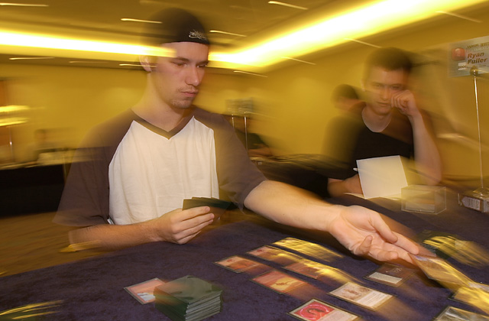
I started and the game was exactly what I hoped, the first to put down knights would win. Although he played Hypnotic Specter on the first turn, I killed it with Swords, the life exchange was 2 to 2, but he played Drain Life and Zuran Orb that revived him which complicated everything. But I also played a Zuran Orb and made the game go longer, but the difference was I had played much more land (some 7 or 8). I played my knights and made him eat all his land, and at the end killed him. In the second game he mulliganed and still repeated the 1st-turn Specter and this time I didn't have Swords, but in its place I had three Lions, which with their aggressiveness kept Ryan from attacking with the Specter. Without lands he didn't have any other option but to wait for the lions to beat him. Result: 2-0, in the format 3-0 and total 6-6, finally I had reached an acceptable record and could hope for a 3rd or 4th place finish. I was too content.
My biggest problem was that only 3 rounds remained, but it was the worst format, Type 1. Like I mentioned at the start I was going to play an Extended mono red, changing 8 cards. With this I didn't hope for much in reality.
13th Round vs. Gary Wise (blue-black control with Masticores)
This is another game I don't want to comment on other than it went very badly. Result: 0-2
14th Round vs. Dave Price (Type 1 deck)
With his deck of Su-Chis and Juggernauts I still hoped to win, but it wouldn't be an easy road. In the first game a few Bolts and a Fireblast left him seeing stars. In the second game he played a Mind Twist that killed my hand, then played 2 Su-Chis that were the worst thing I could have seen. I couldn't do anything and they ended up killing me. The third game I had an excellent hand that could only lose if he played Mind Twist, and I lost. Know why? Because he played Mind Twist. Still I was close to winning the game but as it was during the whole Invitational, I couldn't draw a Mountain and for that lost. Once more a land made me lose. Buh!
15th and last round vs. Yoshikazu Ishii (who was playing the same thing I was, Extended red)
This time I was on an even playing field, and I had only the goal of finishing higher than him. That's what my friends told me, and if I didn't they wouldn't accept me when I returned to Mexico.
Fortunately for me the games favored me because of the bad luck of Ishii. I don't like to win that way but it still is worth the same. Of this match I remember a rain of bolts and sparks, ah! And a Cadet that managed to do 8 damage. This was the story of the last Type 1 match and the Invitational.
Result: 2-1, in type 1, 1-2 and in general 7-8, and so ended my participation with a decent EIGHTH place, I ended the tournament satisfied since I felt that through the whole thing I played at a good level. But what made me most content and made it worth the effort was my victory over Jon Finkel.
Jajajajajajaja I succeeded in beating the best player in the world (it isn't a joke, man! Simply too much happiness).
For me and for Latin America, having a representative in the all-star game of Magic, the Magic Invitational is a big step, and I hope that this is the start that drives an increase in the play level of Latin America. To end this report I want to thank all the players, since in every moment they behaved in the best way with me. There wasn't any that had a bad attitude toward me. Thanks to Mark Rosewater, Jeff, to Matt Vienneau who shared a room with me, and finally all those that were around at the invitational.
THANK YOU!
Gerardo "Chiclick" Godinez
Ah! I forgot, thank you to Wizards of the Coast.

